**Events Report**

**World Children’s Day and Child Rights Week- 2021**

**Submitted by:**

Bangladesh Shishu Adhikar Forum (BSAF)

**Supported by:**

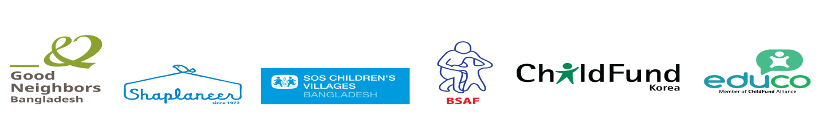

**Introduction:**

Each year Bangladesh government observers the International Children’s Day on the First Monday of October and declares the week as the Child Rights Week, to raise the awareness on the rights of the Children. CSOs across the country observe the Child Rights organizations observe the week with due importance.

This year Bangladesh Government declared 04 October- 10 October, 2021 as the Child Rights Week-2021. Along with the Ministry of Women and Children Affairs (MoWCA), Bangladesh Shishu Adhikar Forum (BSAF) observed the week with different activities. All the activities were participated by children. The theme of the week, as decided by the government, was "শিশুর জন্য বিনিয়োগ করি, সমৃদ্ধ বিশ্ব গড়ি”. The theme has been translated by the National Child Rights Week Observance Committee (NCRWOC) under the Ministry of Women and Child Affairs (MOWCA) from its original English version developed by UNICEF Headquarters.

As a national network of child rights NGOs, BSAF chalked out several plans to observe the Child Rights Week-2021 highlighting its significance and appeal. BSAF along with 4 INGOs: SOS Children’s Village International in Bangladesh, Shapla Neer, Educo and Good Neighbors Bangladesh worked together to celebrate the CR week in a vibrant manner.

This year BSAF chalked out some events to observe the CR Week 2021 keeping the Covid 19 pandemic situation in mind. BSAF and collaborating INGOs decided in their preparatory meeting to observe Child Rights Week 2021 by sticker campaign, art competition and childrens’ discussion on TV channel. BSAF got the slot to organize the Art Competition on 06 October, 2021 at 11.00 AM at UDDUPAN venue.

***Nationwide Sticker Campaign***

To observe Child Rights Week 2021 in Bangladesh; BSAF, with the support of some INGOs in Bangladesh brought out 2 types of colorful sticker focusing the theme on children’s rights and their protection. BSAF distributed stickers among NGOs /INGOs and other concerned stakeholders across the country. BSAF printed 10000 stickers to observe the Child Rights Week and distributed to the following organizations:

|  |
| --- |
| * Different Ministries, Govt. Departments and local administrations - 1000 * NGOs, INGOs and other stakeholders - 8500 |

Through the Sticker campaign BSAF has tried to popularize the following demands among the people that were claimed to the government:

* Take effective measures to address critical child labor situation caused by the consequences of COVID-19.
* Update the hazardous job list for children incorporating the child domestic work.
* Formulate National Alternative Care Policy to ensure quality alternative care for children depriving of parental care.
* Ensure child safety for prosperity.

|  |  |
| --- | --- |
| 1632985248475.jpg | 1633245372670 (1).jpg |

Sticker Transparent (3000 pcs) Sticker Paper (7000 pcs)

***Children’s discussion on TV channel***

To increase child participation and create scope of raising children’s voice about child rights, BSAF organized a dialogue/talk show on Child Rights Week 2021. The dialogue was participated by 4 working children from different sectors. In the dialogue session children shared their experience and expectations to the government and the people as a whole..

The program was recorded on 4th October 2021 at the RTV studio and telecasted on 06th October 2021 Wednesday at 5.00 PM. The dialogue session was anchored by Mr. Abdullah Al Mamun, Child Rights Activist.

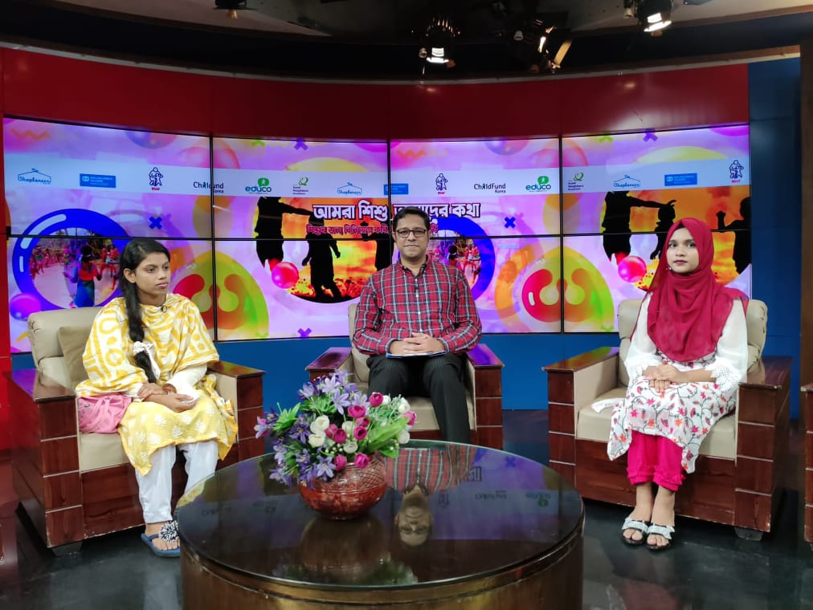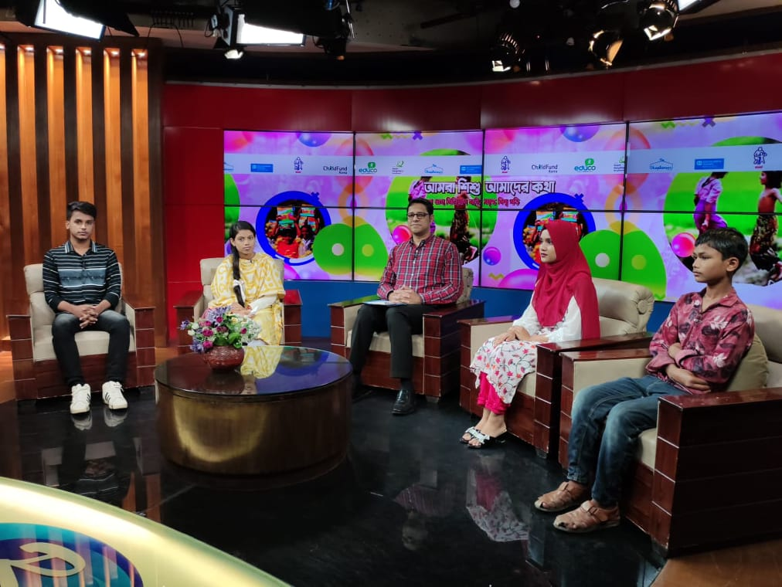

***Art Competition***

BSAF organized an art competition for the working children for observing child rights week on 06 October 2021. The event was held at UDDIPAN auditorium in Dhaka. Children from different MNGOs and INGOs participated in the art competition. By considering their innovation and painting, the judges gave award for 5 best paintings. Jannatul Suraiya (15) from Good Neighbours Bangladesh became the first in this competition. Besides, Asif Babu (15) from SOS Children’s Village won the second prize, Lamia (11) from ASD stood third, Suraiya (14) from Educo stood fourth and Hasina (13) from Shapla Neer stood fifth in the art competition. However all the participants of the art competition were given special prizes in appreciation to their effort.

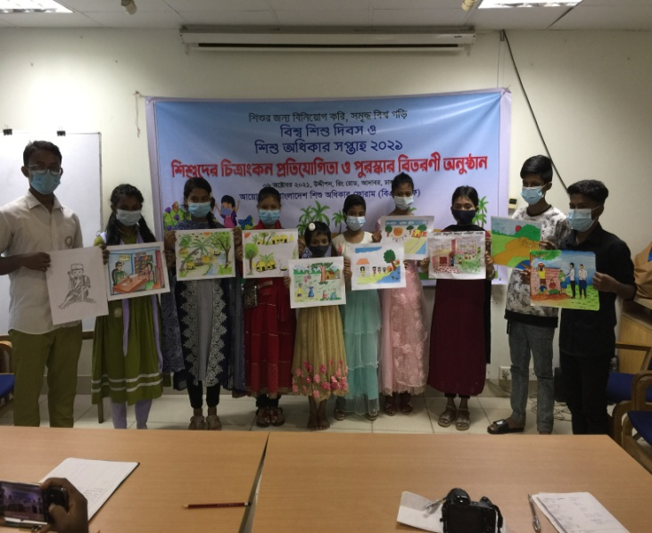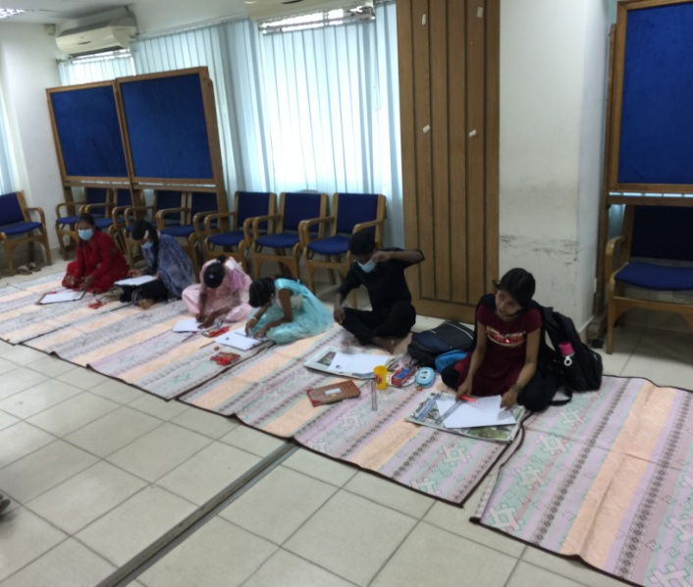

**Strength of the events:**

* Children got opportunity to reflect their creativity through art and painting.
* Children could convey their messages directly to the duty bearers and mass people through participating in the TV talk show.
* Through taking part in the TV talk show they shown their potentials.
* The message quoted in the stickers will remind everybody about their responsibility to the children.

--- 0 ---